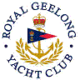 | Royal Geelong Yacht Club Inc.  Est 1859
Trophy Deed of Gift.

Trophy: | Festival of Sails Division 1 IRC Champion
Presented by:
Date: | 2007
For:
Remarks / Revisions
Click HERE for a List of Recipients

